
A10
Sreenidhi Institute of Science and Technology
(An Autonomous Institution)
Code No: 101MA05
B. TECH. II-Year I-Semester Examinations, December 2015 (Supplementary)
MATHEMATICAL TOOLS (ECM)

Time: 3 Hours Max. Marks: 70

Note: No additional answer sheets will be provided.

Part - A
Max.Marks:20

Answer all QUESTIONS. EACH QUESTION CARRIES 2 MARKS.
- Given p(A)=1/4 ,p(B)=1/3 and p(AUB)=1/2 , evaluate p(A∩B’) and p(A/B’).
- Find by Iterative method (4 iterations).
- Find poles for f (z) = ; f (z) = z.
- Eliminate the arbitrary constants and from to obtain the PDE governing it.
- Find the Fourier Transform of f(t)=sin at .
- Express in terms of gamma function.
- Solve y'=y² + x, y(0)=1 using Taylors theorem method and computey(0.1)
- Write the Cauchy Riemann equations in polar coordinate system.
- Form the PDE by eliminating arbitrary constant x.
- Find the value of β (2.5, 1.5).
Part – B
Max.Marks:50

ANSWER ANY FIVE QUESTIONS. EACH QUESTION CARRIES 10 MARKS.
- a) Use Beta and Gama function evaluate 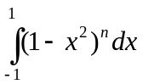
b) Show that 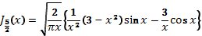

2. Find the Fourier integral transform of
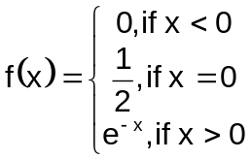
and hence deduce that
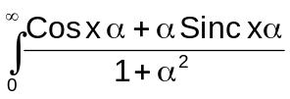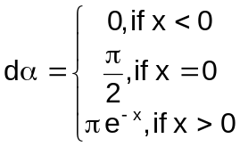

3. a. Determine the analytic function whose real part is)
b. Evaluate where using Cauchy’s integral formula where C is |z-1|=1/2 using Cauchy integral formula.

4. a. A car hire firm has two cars which it hires out day by day .The number of demands for a car on each day is distributed as a poison distribution, with mean 1.5. Calculate the proportion of days
(i) On which there is no demand (II) on which demand is refused
(

b. The mean and S.D of marks obtained by 1000 students in an examination are respectively 34.4 and 16.5 .Assume normality of the distribution, find the approximate number of students expected to obtain marks between 30 and 60.

5. Find a real root of the equation, using the Newton Raphson method.
6. Given 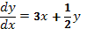 with the condition, by using the Runge-Kutta fourth order method.

7. a) Find the correlation coefficient between x and y from the given data
x: 78 89 97 69 59 79 68 57
y: 125 137 156 112 107 138 123 108

b) If x continuous random variable with probability density given by
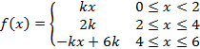
Find k and mean value of x.

8. a. Use method of false position to find the x+= 3.375.

b. Apply Runge-Kutta fourth order method to find y when x=0.2 when dy/dx= x+y and y=1 when x=0.

-- 00 -- 00 --

